

# MSPM’S

# DEOGIRI INSTITUTE OF ENGINEERING AND MANAGEMENT STUDIES, AURANGABAD

Department of Computer science and Engineering

Survey Based Project Reporton: **OPPO F7&OPPO A3S**

**Subject: Computer architecture and Organization**

Submitted By: **Shweta kharat(26053) & Hrishikesh Dharurkar(26054)**

Under the guidance of

**Prof. P. H. Durole**

Asst. Prof. Department of CSE

(Deogiri Institute of Engineering and Management Studies)

2019-2020



**OPPO A3S**

|  |  |
| --- | --- |
| **NETWORK** | |
| **Technology** | GSM / HSPA / LTE |
| [**2G bands**](https://m.gsmarena.com/network-bands.php3) | GSM 850 / 900 / 1800 / 1900 - SIM 1 & SIM 2 |
| [**3G bands**](https://m.gsmarena.com/network-bands.php3) | HSDPA 850 / 900 / 2100 |
| [**4G bands**](https://m.gsmarena.com/network-bands.php3) | LTE band 1(2100), 3(1800), 5(850), 8(900), 38(2600), 40(2300), 41(2500) |
| [**Speed**](https://m.gsmarena.com/glossary.php3?term=3g) | HSPA 42.2/5.76 Mbps, LTE-A (2CA) Cat6 300/50 Mbps |

|  |  |
| --- | --- |
| **LAUNCH** | |
|  |  |
| **Announced** | 2018, July |
| **Status** | Available. Released 2018, July |

|  |  |
| --- | --- |
| **BODY** | |
| [**Dimensions**](https://m-gsmarena-com.cdn.ampproject.org/v/s/m.gsmarena.com/oppo_a3s-ampp-9269.php?amp_js_v=a2&amp_gsa=1&usqp=mq331AQEKAFwAQ%3D%3D) | 156.2 x 75.6 x 8.2 mm (6.15 x 2.98 x 0.32 in) |
| [**Weight**](https://m-gsmarena-com.cdn.ampproject.org/v/s/m.gsmarena.com/oppo_a3s-ampp-9269.php?amp_js_v=a2&amp_gsa=1&usqp=mq331AQEKAFwAQ%3D%3D) | 168 g (5.93 oz) |
| [**SIM**](https://m.gsmarena.com/glossary.php3?term=sim) | Dual SIM (Nano-SIM, dual stand-by) |

|  |  |
| --- | --- |
| **DISPLAY** | |
| [**Type**](https://m.gsmarena.com/glossary.php3?term=display-type) | IPS LCD capacitive touchscreen, 16M colors |
| [**Size**](https://m-gsmarena-com.cdn.ampproject.org/v/s/m.gsmarena.com/oppo_a3s-ampp-9269.php?amp_js_v=a2&amp_gsa=1&usqp=mq331AQEKAFwAQ%3D%3D) | 6.2 inches, 95.9 cm2 (~81.2% screen-to-body ratio) |
| [**Resolution**](https://m.gsmarena.com/glossary.php3?term=resolution) | 720 x 1520 pixels, 19:9 ratio (~271 ppi density) |
| [**Protection**](https://m.gsmarena.com/glossary.php3?term=screen-protection) | Corning Gorilla Glass 3 |

|  |  |
| --- | --- |
| **PLATFORM** | |
| [**OS**](https://m.gsmarena.com/glossary.php3?term=os) | Android 8.1 (Oreo); ColorOS 5.1 |
| [**Chipset**](https://m.gsmarena.com/glossary.php3?term=chipset) | Qualcomm SDM450 Snapdragon 450 (14 nm) |
| [**CPU**](https://m.gsmarena.com/glossary.php3?term=cpu) | Octa-core 1.8 GHz Cortex-A53 |
| [**GPU**](https://m.gsmarena.com/glossary.php3?term=gpu) | Adreno 506 |

|  |  |
| --- | --- |
| **MEMORY** | |
| [**Card slot**](https://m.gsmarena.com/glossary.php3?term=memory-card-slot) | microSD, up to 256 GB (dedicated slot) |
| [**Internal**](https://m.gsmarena.com/glossary.php3?term=dynamic-memory) | 16GB 2GB RAM, 32GB 3GB RAM, 64GB 4GB RAM |

|  |  |
| --- | --- |
| **MAIN CAMERA** | |
| [**Dual**](https://m.gsmarena.com/glossary.php3?term=camera) | 13 MP, f/2.2, AF 2 MP, f/2.4, depth sensor |
| [**Features**](https://m.gsmarena.com/glossary.php3?term=camera) | LED flash, HDR, panorama |
| [**Video**](https://m.gsmarena.com/glossary.php3?term=camera) | 1080p@30fps |

|  |  |
| --- | --- |
| **SELFIE CAMERA** | |
| [**Single**](https://m.gsmarena.com/glossary.php3?term=secondary-camera) | 8 MP, f/2.2 |
| [**Video**](https://m.gsmarena.com/glossary.php3?term=secondary-camera) |  |

|  |  |
| --- | --- |
| **SOUND** | |
| [**Loudspeaker**](https://m.gsmarena.com/glossary.php3?term=loudspeaker) | Yes |
| [**3.5mm jack**](https://m.gsmarena.com/glossary.php3?term=audio-jack) | Yes |
|  | Active noise cancellation with dedicated mic |

|  |  |
| --- | --- |
| **COMMS** | |
| [**WLAN**](https://m.gsmarena.com/glossary.php3?term=wi-fi) | Wi-Fi 802.11 b/g/n, Wi-Fi Direct, hotspot |
| [**Bluetooth**](https://m.gsmarena.com/glossary.php3?term=bluetooth) | 4.2, A2DP, LE |
| [**GPS**](https://m.gsmarena.com/glossary.php3?term=gps) | Yes, with A-GPS |
| [**Radio**](https://m.gsmarena.com/glossary.php3?term=fm-radio) | FM radio |
| [**USB**](https://m.gsmarena.com/glossary.php3?term=usb) | microUSB 2.0, USB On-The-Go |

|  |  |
| --- | --- |
| **FEATURES** | |
| [**Sensors**](https://m.gsmarena.com/glossary.php3?term=sensors) | Accelerometer, gyro, proximity, compass |
| [**Messaging**](https://m.gsmarena.com/glossary.php3?term=messaging) | SMS(threaded view), MMS, Email, Push Email, IM |
| [**Browser**](https://m.gsmarena.com/glossary.php3?term=browser) | HTML5 |

|  |  |
| --- | --- |
| **BATTERY** | |
|  | Non-removable Li-Ion 4230 mAh battery |
| [**Charging**](https://m.gsmarena.com/glossary.php3?term=battery-charging) | Fast battery charging 20W (VOOC Flash Charge) |

|  |  |
| --- | --- |
| **MISC** | |
| [**Colors**](https://m-gsmarena-com.cdn.ampproject.org/v/s/m.gsmarena.com/oppo_a3s-ampp-9269.php?amp_js_v=a2&amp_gsa=1&usqp=mq331AQEKAFwAQ%3D%3D) | Red, Dark Purple |
| [**Models**](https://m.gsmarena.com/glossary.php3?term=models) | CPH1803, CPH1853 |
| [**Price**](https://m-gsmarena-com.cdn.ampproject.org/v/s/m.gsmarena.com/oppo_a3s-ampp-9269.php?amp_js_v=a2&amp_gsa=1&usqp=mq331AQEKAFwAQ%3D%3D) | About 11000 INR |

* INSTRUCTION SET:

The ARMv8-A instruction sets

The A64 instruction set is similar to the existing A32 instruction set. The instructions themselves  are still 32 bits wide and have similar syntax. The instruction sets use a generic naming convention within the ARMv8-A architecture, so that the original 32-bit instruction set states are now called:

**A32:** When in AArch32 state, the instruction set is largely compatible with ARMv7-A, though there are differences. It also provides some new instructions to align with some of the features that are introduced in the A64 instruction set.

**T32**: The Thumb instruction set was first included in the ARM7TDMI processor and originally contained only 16-bit instructions. 16-bit instructions gave much smaller programs at the cost of some performance. ARMv7-A processors, including those in the Cortex-A series, support Thumb-2 technology, which extends the Thumb instruction set to provide a mix of 16-bit and 32-bit instructions. This gives performance similar to that of ARM, while retaining the reduced code size. Because of its size and performance advantages, it is increasingly common for all 32-bit code to be compiled or assembled to take advantage of Thumb-2 technology.

In keeping with the naming convention, and reflecting the 64-bit operation, the instruction set for AArch64 is called A64.

All A64 instructions are the same length, unlike T32, which is a variable-length instruction set. This makes management and tracking of generated code sequences easier, particularly affecting dynamic code generators.

* Switching between instruction sets

Switching between instruction sets It is not possible to use code from the two Execution states within a single application. There is no interworking between A64 and A32 or T32 instruction sets in ARMv8-A as there is between A32 and T32 instruction sets. Code that is written in A64 for the ARMv8-A processors cannot run on ARMv7-A Cortex®-A series processors. However, code that is written for ARMv7-A processors can run on ARMv8-A processors in the AArch32 Execution state. This is summarized in the following figure.

* Addressing

When the processor can store 64-bit values in a single register, it becomes much simpler to access large amounts of memory within a program. A single thread executing on a 32-bit core is limited to accessing 4GB of address space. Large parts of that addressable space are reserved for use by the OS kernel, library code, peripherals, and more. As a result, lack of space means that the program might need to map some data in or out of memory while executing. Having a larger address space, with 64-bit pointers, avoids this problem. It also makes techniques such as memory-mapped files more attractive and convenient to use. The file contents are mapped into the memory map of a thread, even though the physical RAM might not be large enough to contain the whole file.

* **A32 instruction groups**

|  |  |
| --- | --- |
| **Instruction group** | **Description** |
| Branch and control | These instructions do the following:   * Branch to subroutines. * Branch backwards to form loops. * Branch forward in conditional structures. * Make the following instruction conditional without branching. * Change the processor between A32 state and T32 state. |
| Data processing | These instructions operate on the general-purpose registers. They can perform operations such as addition, subtraction, or bitwise logic on the contents of two registers and place the result in a third register. They can also operate on the value in a single register, or on a value in a register and an immediate value supplied within the instruction.  Long multiply instructions give a 64-bit result in two registers. |
| Register load and store | These instructions load or store the value of a single register from or to memory. They can load or store a 32-bit word, a 16-bit halfword, or an 8-bit unsigned byte. Byte and halfword loads can either be sign extended or zero extended to fill the 32-bit register.  A few instructions are also defined that can load or store 64-bit doubleword values into two 32-bit registers. |
| Multiple register load and store | These instructions load or store any subset of the general-purpose registers from or to memory. |
| Status register access | These instructions move the contents of a status register to or from a general-purpose register. |

* A64 Instruction Set

The A64 instruction set is supported by the Armv8-A architecture. Key features of A64 include:

* Clean decode table based on 5-bit register specifiers.
* Instruction semantics broadly similar to [A32](https://developer.arm.com/architectures/instruction-sets/base-isas/a32) and [T32](https://developer.arm.com/architectures/instruction-sets/base-isas/t32).
* 31 general-purpose 64-bit registers accessible at all times.
* No modal banking of general purpose registers for improved performance and energy.
* Program counter and stack pointer are not general purpose registers.
* Dedicated zero register available for most instructions.

* **A64 instruction groups**

|  |  |
| --- | --- |
| **Instruction group** | **Description** |
| Branch and control | These instructions do the following:   * Branch to and return from subroutines. * Branch backwards to form loops. * Branch forward in conditional structures. * Generate and return from exceptions. |
| Data processing | These instructions operate on the general-purpose registers. They can perform operations such as addition, subtraction, or bitwise logic on the contents of two registers and place the result in a third register. They can also operate on the value in a single register, or on a value in a register and an immediate value supplied within the instruction.  The addition and subtraction instructions can optionally left shift the immediate operand, or can sign or zero-extend and shift the final source operand register.  A64 includes signed and unsigned 32-bit and 64-bit multiply and divide instructions. |
| Register load and store | These instructions load or store the value of a single register or pair of registers from or to memory. You can load or store a single 64-bit doubleword, 32-bit word, 16-bit halfword, or 8-bit byte, or a pair of words or doublewords. Byte and halfword loads can either be sign-extended or zero-extended to fill the 32-bit register. You can also load and sign-extend a signed byte, halfword or word into a 64-bit register, or load a pair of signed words into two 64-bit registers. |
| System register access | These instructions move the contents of a system register to or from a general-purpose register. |

* **Armv8-A Architecture**

The Armv8-A architecture is the latest generation Arm architecture targeted at the Applications ('A') profile.

It introduces the ability to use 64-bit and 32-bit Execution states, known as AArch64 and AArch32 respectively. The AArch64 Execution state supports the A64 instruction set, holds addresses in 64-bit registers and allows instructions in the base instruction set to use 64-bit registers for their processing. The AArch32 Execution state is a 32-bit Execution state that preserves backwards compatibility with the Armv7-A architecture and enhances that profile so that it can support some features included in the AArch64 state. It supports the [T32](https://developer.arm.com/architectures/instruction-sets/base-isas/t32) and [A32](https://developer.arm.com/architectures/instruction-sets/base-isas/a32) instruction sets.

Armv8-A is the only profile that supports AArch64 execution, where the relationship between AArch64 and AArch32 is known as *interprocessing*. In addition, the Armv8-A architecture allows different levels of AArch64 and AArch32 support, for example:

* AArch64 only designs.
* AArch64 designs that also support AArch32 operating systems/virtual machines.
* AArch64 support with AArch32 at (unprivileged) application level only

**ARCHITECTURE OF SD 450 PROCESSOR**

* Snapdragon 450 is an octa-core processor and the first 14nm chip in the 400 series.
* On May 9, 2017, Qualcomm introduced their mobile processors, the Snapdragon 630 and Snapdragon 660. Now the company has released a new mobile platform, the Snapdragon 450. Currently, Snapdragon 435 is the king of the 400 series and is present in smartphones like Redmi 4X and Huawei Y7 Prime.
* The Snapdragon 450 is an octa-core processor. It is the first 14nm chip in the 400 series. All its predecessors are based on 28nm designs. The processor has 8 ARM Cortex-A53 cores with clock speeds of 1.8 GHz.The Qualcomm Technologies advanced 64-bit CPU architecture is designed to tackle the toughest mobile workloads. The firm claims that its Qualcomm Adreno 506 GPU gives upto 25% higher performance.
* The Qualcomm Snapdragon 450 processor adds more value to 400 series by enhancing the power performance, camera, and multimedia and connectivity technologies. The launch time of the apps are faster. Upto 20% faster app launch time for social apps and emails, 15% for Maps and over 10% for Games.
* *Display*: Supports high-quality display plus enhanced power saving.
* *Battery*: The Snapdragon 450 provides upto 4 hours longer battery life and 25% higher. It has Qualcomm Quick Charge 3.0 which enables zero to 85% charge in just 35 minutes and is upto 27% faster and 45% more efficient than its prior generations.
* *Camera and video:* The Snapdragon 450 is the first in the 400-tier to support real-time Bokeh effects. It is also designed to improve on previous generations by including support for enhanced dual camera at 13+13MP, or single camera support up to 21MP; hybrid autofocus; and 1080p video capture and playback at up to 60fps, enabling slow motion capture. The Snapdragon 450 also includes support for 1920x1200 full HD displays, as well as the Qualcomm Hexagon DSP, which enables multimedia, camera and sensor processing at greater performance and lower power than the previous generation.

* *USB*: This new processor has improved USB, USB 3.0. This USB significantly decreases the download time and enables faster data transfer. Maximum download speed becomes 5 Gbps. Snapdragon 450 is the first in its tier to support fast data transfer.
* Along with these features, the Qualcomm Snapdragon 450 supports additional features Power Management, Speaker amp, touch, fingerprint, LTE version, spectral band and Audio Codec.
* 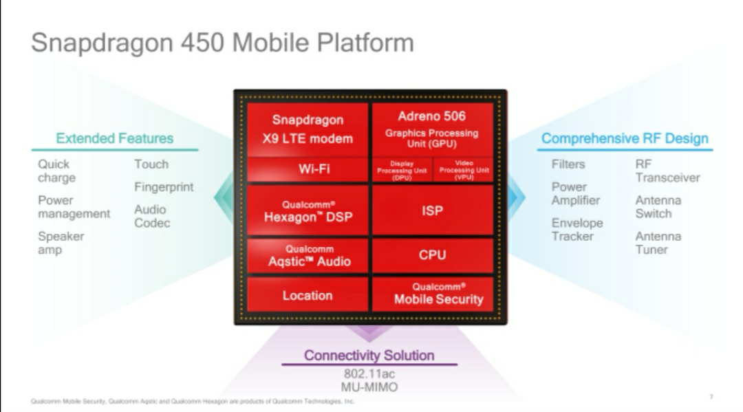

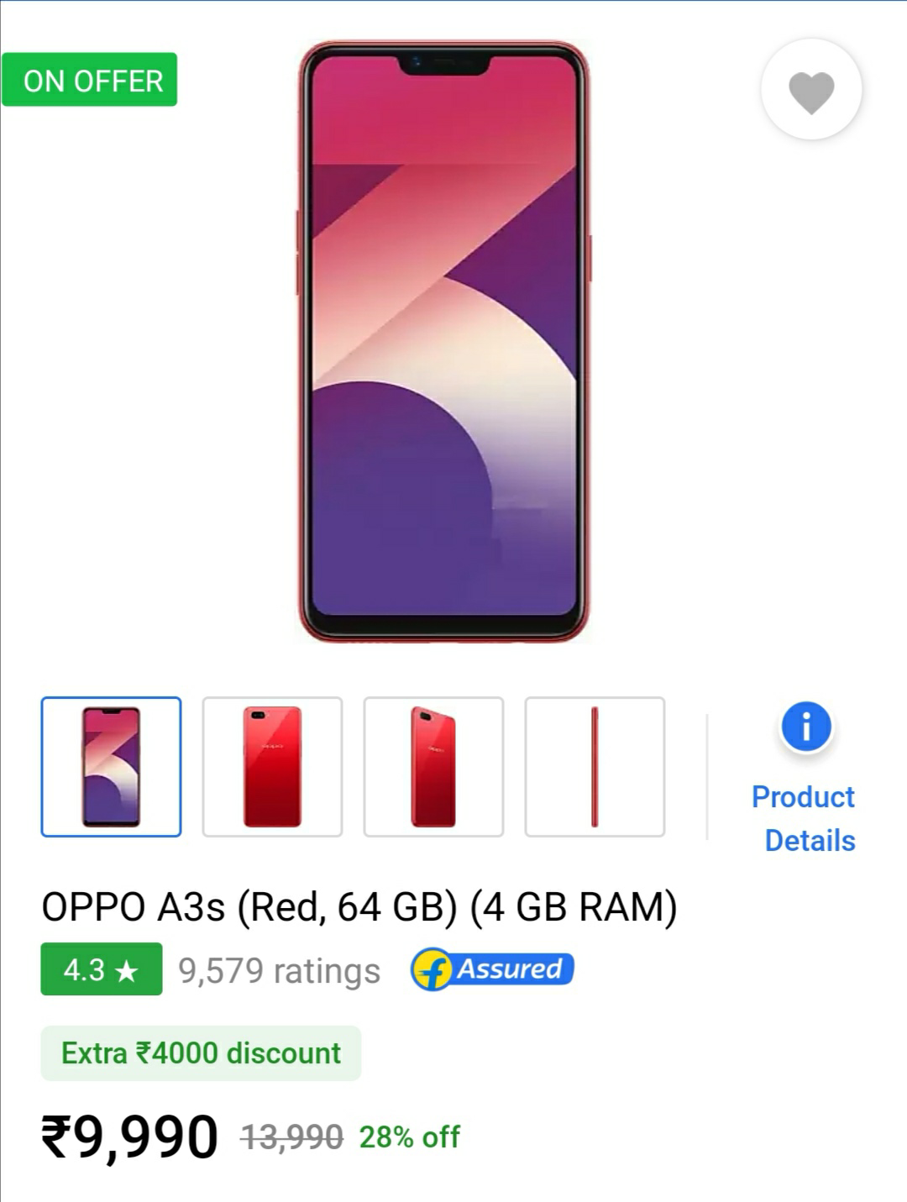

|  |  |  |
| --- | --- | --- |
| *Change compare mode* | Oppo A3 MORE PICTURES   * [**Specs**](https://m.gsmarena.com/oppo_a3-9168.php) | Oppo F7 MORE PICTURES   * [**Review**](https://m.gsmarena.com/oppo_f7-review-1759.php) * [**Specs**](https://m.gsmarena.com/oppo_f7-9121.php) |

|  |  |  |
| --- | --- | --- |
|  | [Oppo A3](https://m.gsmarena.com/oppo_a3-9168.php) | [Oppo F7](https://m.gsmarena.com/oppo_f7-9121.php) |

|  |  |  |
| --- | --- | --- |
| **NETWORK** | | |
| [**Technology**](https://m.gsmarena.com/compare.php3?idPhone1=9168&idPhone2=9121) | GSM / CDMA / HSPA / LTE | GSM / HSPA / LTE |
| [**2G bands**](https://m.gsmarena.com/network-bands.php3) | GSM 850 / 900 / 1800 / 1900 - SIM 1 & SIM 2 | GSM 850 / 900 / 1800 / 1900 - SIM 1 & SIM 2 |
|  | CDMA 800 & TD-SCDMA |  |
| [**3G Network**](https://m.gsmarena.com/network-bands.php3) | HSDPA 850 / 900 / 1900 / 2100 | HSDPA 850 / 900 / 2100 |
|  | HSDPA 850 / 1700(AWS) / 1900 / 2100 |  |
| [**4G Network**](https://m.gsmarena.com/network-bands.php3) | LTE band 1(2100), 3(1800), 5(850), 7(2600), 8(900), 34(2000), 38(2600), 39(1900), 40(2300), 41(2500) | LTE band 1(2100), 3(1800), 5(850), 8(900), 38(2600), 40(2300), 41(2500) |
|  | LTE band 1(2100), 3(1800), 4(1700/2100), 5(850), 8(900), 34(2000), 38(2600), 39(1900), 40(2300), 41(2500) |  |
| [**Speed**](https://m.gsmarena.com/glossary.php3?term=3g) | HSPA 42.2/5.76 Mbps, LTE-A (2CA) Cat13 600/100 Mbps | HSPA 42.2/5.76 Mbps, LTE-A (2CA) Cat13 600/100 Mbps |

|  |  |  |
| --- | --- | --- |
| **LAUNCH** | | |
| [**Announced**](https://m.gsmarena.com/compare.php3?idPhone1=9168&idPhone2=9121) | 2018, April | 2018, March |
| [**Status**](https://m.gsmarena.com/compare.php3?idPhone1=9168&idPhone2=9121) | Available. Released 2018, May | Available. Released 2018, April |

|  |  |  |
| --- | --- | --- |
| **BODY** | | |
| [**Dimensions**](https://m.gsmarena.com/compare.php3?idPhone1=9168&idPhone2=9121) | 156 x 75.3 x 7.8 mm (6.14 x 2.96 x 0.31 in) | 156 x 75.3 x 7.8 mm (6.14 x 2.96 x 0.31 in) |
| [**Weight**](https://m.gsmarena.com/compare.php3?idPhone1=9168&idPhone2=9121) | 159 g (5.61 oz) | 158 g (5.57 oz) |
| [**SIM**](https://m.gsmarena.com/glossary.php3?term=sim) | Dual SIM (Nano-SIM, dual stand-by) | Dual SIM (Nano-SIM, dual stand-by) |

|  |  |  |
| --- | --- | --- |
| **DISPLAY** | | |
| [**Type**](https://m.gsmarena.com/glossary.php3?term=display-type) | LTPS IPS LCD capacitive touchscreen, 16M colors | LTPS IPS LCD capacitive touchscreen, 16M colors |
| [**Size**](https://m.gsmarena.com/compare.php3?idPhone1=9168&idPhone2=9121) | 6.2 inches, 96.9 cm2(~82.5% screen-to-body ratio) | 6.23 inches, 96.9 cm2(~82.5% screen-to-body ratio) |
| [**Resolution**](https://m.gsmarena.com/glossary.php3?term=resolution) | 1080 x 2280 pixels, 19:9 ratio (~405 ppi density) | 1080 x 2280 pixels, 19:9 ratio (~405 ppi density) |
| [**Protection**](https://m.gsmarena.com/glossary.php3?term=screen-protection) |  | Corning Gorilla Glass 5 |

|  |  |  |
| --- | --- | --- |
| **PLATFORM** | | |
| [**OS**](https://m.gsmarena.com/glossary.php3?term=os) | Android 8.1 (Oreo); ColorOS 5 | Android 8.1 (Oreo); ColorOS 5 |
| [**Chipset**](https://m.gsmarena.com/glossary.php3?term=chipset) | Mediatek MT6771 Helio P60 (12 nm) | Mediatek MT6771 Helio P60 (12 nm) |
| [**CPU**](https://m.gsmarena.com/glossary.php3?term=cpu) | Octa-core (4x2.0 GHz Cortex-A73 & 4x2.0 GHz Cortex-A53) | Octa-core (4x2.0 GHz Cortex-A73 & 4x2.0 GHz Cortex-A53) |
| [**GPU**](https://m.gsmarena.com/glossary.php3?term=gpu) | Mali-G72 MP3 | Mali-G72 MP3 |

|  |  |  |
| --- | --- | --- |
| **MEMORY** | | |
| [**Card slot**](https://m.gsmarena.com/glossary.php3?term=memory-card-slot) | microSD, up to 256 GB (dedicated slot) | microSD, up to 256 GB (dedicated slot) |
| [**Internal**](https://m.gsmarena.com/glossary.php3?term=dynamic-memory) | 128GB 4GB RAM | 64GB 4GB RAM, 128GB 6GB RAM |

|  |  |  |
| --- | --- | --- |
| **MAIN CAMERA** | | |
| [**Modules**](https://m.gsmarena.com/glossary.php3?term=camera) | 16 MP, f/1.8, PDAF | 16 MP, f/1.8, PDAF |
| [**Features**](https://m.gsmarena.com/glossary.php3?term=camera) | LED flash, HDR, panorama | LED flash, HDR, panorama |
| [**Video**](https://m.gsmarena.com/glossary.php3?term=camera) | 1080p@30fps | 1080p@30fps |

|  |  |  |
| --- | --- | --- |
| **SELFIE CAMERA** | | |
| [**Modules**](https://m.gsmarena.com/glossary.php3?term=camera) | 8 MP, f/2.2 | 25 MP, f/2.0, 1/2.8", 0.9µm |
| [**Video**](https://m.gsmarena.com/glossary.php3?term=camera) |  | 1080p@30fps |

|  |  |  |
| --- | --- | --- |
| **SOUND** | | |
| [**Loudspeaker**](https://m.gsmarena.com/glossary.php3?term=loudspeaker) | Yes | Yes |
| [**3.5mm jack**](https://m.gsmarena.com/glossary.php3?term=audio-jack) | Yes | Yes |
|  | Active noise cancellation with dedicated mic | Active noise cancellation with dedicated mic |

|  |  |  |
| --- | --- | --- |
| **COMMS** | | |
| [**WLAN**](https://m.gsmarena.com/glossary.php3?term=wi-fi) | Wi-Fi 802.11 b/g/n/ac, dual-band, Wi-Fi Direct, hotspot | Wi-Fi 802.11 a/b/g/n/ac, dual-band, Wi-Fi Direct, hotspot |
| [**Bluetooth**](https://m.gsmarena.com/glossary.php3?term=bluetooth) | 4.2, A2DP, LE | 4.2, A2DP, LE |
| [**GPS**](https://m.gsmarena.com/glossary.php3?term=gps) | Yes, with A-GPS | Yes, with A-GPS |
| [**Infrared port**](https://m.gsmarena.com/glossary.php3?term=irda) | No | No |
| [**Radio**](https://m.gsmarena.com/glossary.php3?term=fm-radio) | FM radio | FM radio |
| [**USB**](https://m.gsmarena.com/glossary.php3?term=usb) | microUSB 2.0, USB On-The-Go | microUSB 2.0, USB On-The-Go |

|  |  |  |
| --- | --- | --- |
| **FEATURES** | | |
| [**Sensors**](https://m.gsmarena.com/glossary.php3?term=sensors) | Accelerometer, gyro, proximity, compass | Fingerprint (rear-mounted), accelerometer, gyro, proximity, compass |

|  |  |  |
| --- | --- | --- |
| **BATTERY** | | |
|  | Non-removable Li-Ion 3400 mAh battery | Non-removable Li-Ion 3400 mAh battery |
| [**Stand-by**](https://m.gsmarena.com/glossary.php3?term=stand-by-time) |  |  |
| [**Talk time**](https://m.gsmarena.com/glossary.php3?term=talk-time) |  |  |

|  |  |  |
| --- | --- | --- |
| **MISC** | | |
|  |  |  |
| [**Colors**](https://m.gsmarena.com/compare.php3?idPhone1=9168&idPhone2=9121) | Knight Black, Soybean Meal, Stardust Silver, Garnet Red | Solar Red, Diamond Black, Moonlight Silver (64GB only) |
| [**Price**](https://m.gsmarena.com/compare.php3?idPhone1=9168&idPhone2=9121) | About 330 EUR | About 270 EUR |

|  |  |  |
| --- | --- | --- |
| **TESTS** | | |
| [**Performance**](https://m.gsmarena.com/glossary.php3?term=benchmarking) |  | Basemark OS II: 2058 / Basemark OS II 2.0: 1953 Basemark X: 11873 |
| [**Display**](https://m.gsmarena.com/gsmarena_lab_tests-review-751p2.php) |  | [Contrast ratio: 1956:1 (nominal), 3.333 (sunlight)](https://m.gsmarena.com/oppo_f7-review-1759p3.php#dt) |
| [**Loudspeaker**](https://m.gsmarena.com/gsmarena_lab_tests-review-751p3.php) |  | [Voice 68dB, noise 73dB, ring 84dB](https://m.gsmarena.com/oppo_f7-review-1759p3.php#lt) |
| [**Audio quality**](https://m.gsmarena.com/gsmarena_lab_tests-review-751p4.php) |  | [Noise -92.5dB / Crosstalk -91.2dB](https://m.gsmarena.com/oppo_f7-review-1759p3.php#aq) |
| [**Battery life**](https://m.gsmarena.com/gsmarena_lab_tests-review-751p6.php) |  | Endurance rating 91h |



**Oppo F7**

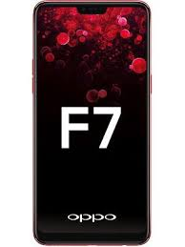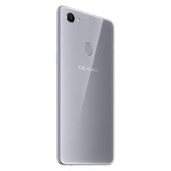

**Specifications:**

**Processor**

[MediaTek Helio P60](https://www.notebookcheck.net/Mediatek-Helio-P60-SoC.301188.0.html)

**Graphics adapter**

[ARM Mali-G72 MP3](https://www.notebookcheck.net/ARM-Mali-G72-MP3-GPU.301008.0.html)

**Memory**

4096 MB

, 4GB or 6GB

**Display**

6.23-inch, 2280 x 1080 pixel 405 PPI, Capacitive, IPS, glossy: yes

**Storage**

64 GB eMMC Flash, 64 GB

, 64GB or 128GB

**Connections**

Audio Connections: 3.5mm, Card Reader: microSD, Sensors: Magnetic, Light Sensor, Proximity, G-Sensor, microUSB

**Networking**

802.11 a/b/g/n/ac (a/b/g/n = Wi-Fi 4/ac = Wi-Fi 5), Bluetooth 4.2, GSM, HSPA, LTE, Dual SIM, GPS

**Size**

height x width x depth (in mm): 7.8 x 156 x 75.3 ( = 0.31 x 6.14 x 2.96 in)

**Operating System**

Android 8.1 Oreo

**Camera**

Primary Camera: 16 MPix f/1.8  
Secondary Camera: 25 MPix f/2.0

**Additional features**

Keyboard: Virtual

**Weight**

158 g (= 5.57 oz / 0.35 pounds) (= 0 oz / 0 pounds)

**Processor:**

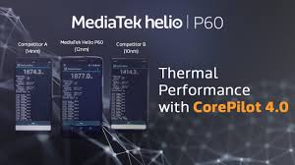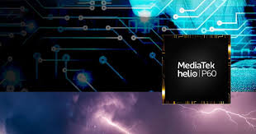

**With the new MediaTek Helio P60, brilliance starts with the engineering on the inside and extends to everything you touch. This chip brings MediaTek   NeuroPilot AI technology to the heart of your smartphone, plus big core power, on-board AI for face detection and AI enhanced smart imaging and video.**

**Built using 12nm technology this chip delivers incredible energy efficiency, longer battery life and is optimized for today's most demanding applications.**

**MediaTek chipsets deliver high-end features and performance so more people than ever can now have access to devices that offer premium experiences without the premium price.**

**MediaTek Helio P60 octa-core design features:**



* Energy efficient TSMC 12nm FinFET production process, combined with MediaTek Core Pilot 4.0 gives sustained high performance with great power efficiency.
* An Arm Mali-G72 MP3 GPU clocked at up to 800MHz, drives performance for the most popular mobile games, resulting in an incredible, smooth experience.
* big. LITTLE architecture pairs four Arm A73 processors at 2.0GHz with four Arm A53 processors at 2.0GHz.
* P60 delivers 70% higher performance than the previous generation MediaTek Helio P23 series chipset.
* **Improved power savings:** Compared to MediaTek Helio P23, P60 delivers up to 25% power savings in heavy duty gaming situations and boasts overall power savings of up to 12 %.

## **STRIKING POWER**

With Core Pilot™ the P60 delivers precise power to keep your device running smooth and cool, yet reliably fast, for heavy gaming, video or multitasking applications. With four big Arm Cortex-A73 processors among its octa-core CPU, this chip packs a powerful punch to meet all of your processing demands.

### **Intelligence**



* Multi-core AI processing unit (Mobile APU) offers deep learning facial recognition, object and scene identification, user behaviour-informed performance and other AI and AR application enhancements.
* APU offers double the power efficiency of the GPU for battery-friendly AI processing.
* MediaTek NeuroPilot AI platform plus SDK automatically manages AI processing and is compliant with Google Android Neural Network API (Android NNAPI).
* Supports common AI frameworks including TensorFlow, TensorFlow Lite, Caffe, Caffe2, custom third-party frameworks and more on the way including ONNX support.

Imaging



* Supersized 24MP+16MP dual-camera or 32MP single-camera with ultra-fast speeds
* Compared to previous Helio P series, the MediaTek Helio P60’s tri-core ISP increases power efficiency by using 18% less power for dual camera setups
* Single or Dual Camera bokeh and depth of field features with a hardware depth engine enabling real-time bokeh preview
* Upgraded multi-frame noise reduction (MFNR)
* Real-time HDR recording and viewing
* Accurate face detection and intelligent scene detection for better auto exposure
* MEMA 3DNR
* Real-time HDR

Connectivity



* 4G LTE World Mode Modem with latest technologies
* IMS (VoLTE\ViLTE\VoWi-Fi): Over 100 cellular operators world-wide
* Dual 4G SIM Dual Standby (DSDS) technology
* Global eMBMS
* HPUE
* MediaTek’s TAS 2.0 smart antenna technology gives optimal and sustained signal quality at the lowest power.
  + Automatically detects and uses the best antenna combination
  + Faster data connection
* 600MHz (Band 71) frequency for North America
* Cat-7 (DL) and Cat-13 (UL)

brilliance Inside

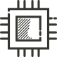

* Multi-core AI processing unit (Mobile APU) offers deep learning facial recognition, object and scene identification, user behaviour-informed performance and other AI and AR application enhancements.
* APU offers double the power efficiency of the GPU for battery-friendly AI processing.
* MediaTek NeuroPilot AI platform plus SDK automatically manages AI processing and is compliant with Google Android Neural Network API (Android NNAPI).
* Supports common AI frameworks including TensorFlow, TensorFlow Lite, Caffe, Caffe2, custom third-party frameworks and more on the way including ONNX support.

RAM

4 GB LPDDR4

The [LPDDR4](https://www.androidauthority.com/tag/LPDDR4) specification aims to double data rates (up to 3200 Mb/s) over last generation RAM and to save on energy consumption for mobile devices. Compared with LPDDR3’s one-channel die, LPDD4 was redesigned for a two-channel die with 16 bits per channel, for a total of 32 bits total. This lowers the core’s power, thanks to shorter data paths, and improves operational speed. The bandwidth target is 17GB/s per die, but can still be arranged in a dual-channel configuration to reach much higher speeds.

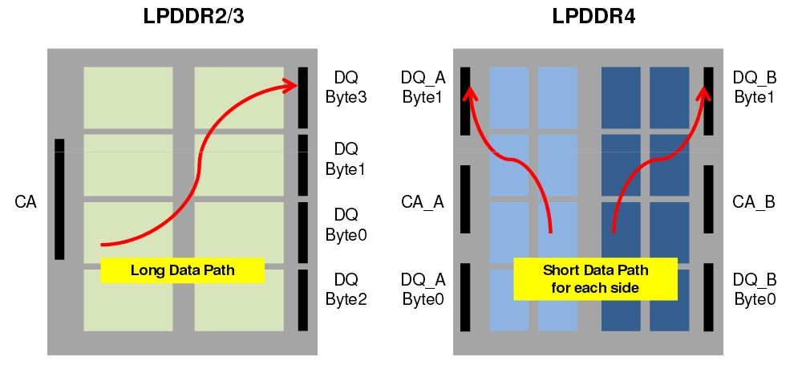

LPDDR4 is architected to meet the power, bandwidth, packaging, cost, and compatibility requirements of the world’s most advanced mobile systems – **Micron**

**STORAGE**

64 GB eMMC Flash, 64 GB

, 64GB or 128GB

eMMC is suitable for high performance applications such as portable consumer electronic products for e.g. smartphones, digital tablets, multi-media players, PDAs, navigational systems and digital cameras. eMMC can thus be used for mobile devices, enhanced storage solutions and as replacement for traditional storage media (i.e., HDDs).

Secondly, eMMC eliminates the need to develop interface software for all types of NAND memory by integrating the embedded controller into the memory chip and providing an easy-to-use memory solutions package for high-speed data transmissions by devices, such as mobile phones. It also eliminates the need for a memory expansion slot by stacking several memory functions vertically, resulting in a very small footprint for the memory devices.

**Battery:**

li-polymer battery

capacity:3400 mah

A **lithium polymer battery**, or more correctly **lithium-ion polymer battery** (abbreviated as **LiPo**, **LIP**, **Li-poly**, **lithium-poly** and others), is a [rechargeable battery](https://en.wikipedia.org/wiki/Rechargeable_battery) of [lithium-ion](https://en.wikipedia.org/wiki/Lithium-ion_battery) technology using a polymer electrolyte instead of a liquid electrolyte. High conductivity semisolid ([gel](https://en.wikipedia.org/wiki/Gel)) polymers form this electrolyte. These batteries provide higher [specific energy](https://en.wikipedia.org/wiki/Specific_energy) than other lithium battery types and are used in applications where weight is a critical feature, like [mobile devices](https://en.wikipedia.org/wiki/Mobile_device) and [radio-controlled aircraft](https://en.wikipedia.org/wiki/Radio-controlled_aircraft).

Quotation:

